Course Number: TBD
Module 6–How We Do It: In-Country Partnerships

Lesson Plan
Course Length: 30 minutes

Boeing proprietary rights are included in the information disclosed herein.

Recipient, by accepting or utilizing this document/media, agrees that neither this document/media nor the information disclosed herein nor any part thereof shall be reproduced or transferred to other documents/media/devices or used or disclosed to others for any other purpose except as specifically authorized in writing by the Boeing company. Any third party disclosure requires prior written approval from the Boeing Company.

Revisions, Additions, and Modifications to This Document
Record any changes made to this document in the table below.
Rev. | Section Modified and Revision Description | Date | Author

Table of Contents
Contents
Instructor Preparation 4
Materials Required 4
Facilities Preparation Required 4
Prerequisites 4
About This Guide 5
Symbols 6
Symbols Used in This Instructor’s Guide 6
Participant Handouts 8
Module 7: How We Do It – Ethics 9
Objectives 10
Instructor Notes 11
Lesson 7.1: Simulating an Ethics Scenario 17
Lesson 7: How We Do It – Ethics 22

Instructor Preparation

Materials Required
- Handouts
- HDMI Cables
- Instructor Guide
- Laptop Computer
- USB Cables

Facilities Preparation Required
- Dry-Erase Markers
- Large Screen TV or Computer Projector
- Roster
- Tables and Chairs
- Whiteboard

Prerequisites
The following prerequisites may be referenced throughout the training:
Title | Description

About This Guide
The Company is committed to offering the best instructional solutions to its employees. As such, this Instructor Guide is designed to meet that commitment while supporting the instructor in leading participants in a traditional classroom environment.

Symbols

Symbols Used in This Instructor’s Guide
Ask. Used to ask a question, such as with Knowledge Checks.
Demonstrate. Used when instructor demonstrates a task.
Do. Used to indicate participant action.
Duration. Used to show amount of time spent on a topic.
Explain. Used to make added emphasis.
Hands-On Activity. Used for a Knowledge Check.
Note. Used when specialized information is presented (e.g., Tighten the aft track fitting screw on the rear leg track to 80 ±8 in-lb).
Objective. Used to focus attention on course or lesson objectives.
Review. Used to review key parts of the lesson, module, or course.
Say. Used to remind instructor to say word-for-word a term or phrase.
Title Slide. Used to delineate title slides for the course.
Transition. Used when switching to a new lesson or topic.
Why This Module Matters. Used to emphasize module content.

Participant Handouts
The following materials will be printed and passed out to the participants:
Title | Description
In-Country Partnerships | PowerPoint that is displayed during training
In-Country Partnerships Overview | Activity used in Knowledge Check at the end of the course

Module 6–How We Do It: In-Country Partnerships
Lesson 6.1: Revitalizing Partnerships for Success
This course provides a general overview of the critical role that In-Country Partnerships will serve in supporting Zhoushan Way principles and mindset, as Completion Center employees resolve obstacles they may infrequently encounter as they create, sustain, and build upon incremental achievements to achieve regional, national, and international greatness. In-Country Partnerships is a general term that helps to highlight for Completion Center employees the value that working cooperatively has had for many companies and persons in China, including this Joint Venture between COMAC and Boeing. This cadre of committed and diligent new employees will be the most recent and enduring examples of how partnering in reaching ambitious business goals will revitalize each employee, families, the region, and beyond Zhoushan.
Lesson Duration
30 Minutes
Why This Lesson Matters
Lesson 6–How We Do It: Revitalizing Partnerships for Success introduces the new employee to the underlying values and principles that govern employee actions and behaviors by referring to several earlier successful partnership efforts in China. Learning how a company with an established history of business success can find partners in other countries, in the way that Boeing has found many valuable associates within this country, promotes trust among employees at the Completion Center. Employees will experience the value of working together in a One Zhoushan Way by learning about earlier efforts that cultivated cooperation and community between partners. A time will be provided for the facilitator to elicit questions and answer concerns or satisfy curiosity that new employees may rightly have.

Objectives
Upon completion of these lessons, the learner will be able to:
- Discuss one or more successful business partnerships Boeing implemented in China
- Describe in general terms one or two specific characteristics that can explain why many believe the Completion Center will achieve profound success in many categories
- Describe the Completion Center and its vital role in cultivating Zhoushan Way thinking in its employees similar to the way that other earlier business partnerships have cultivated harmonious results for many people

Instructor Notes
Content Presentation
 | Lesson 6–How We Do It: In-Country Partnerships Slides XX–XX
 | 5 Minutes
 | Do | Welcome participants to the class and introduce yourself.
 | Ask | Ask participants to introduce themselves. Include:  - Name  - Previous occupation, vocation, or job  - Saying what is hoped you will learn from this lesson

 | Lesson 7: How We Do It – Ethics Slides XX–XX
 | 3 Minutes | REPLACE ABOVE PICTURE WITH CORRECT CONTENT
 | Do | Provide locations of restrooms, break room or lunch and vending area and break times, discuss telephone use policies, review using Microsoft Outlook, and review evacuation plan, and emergency numbers.

 | Lesson 7: How We Do It – Ethics Slides XX–XX
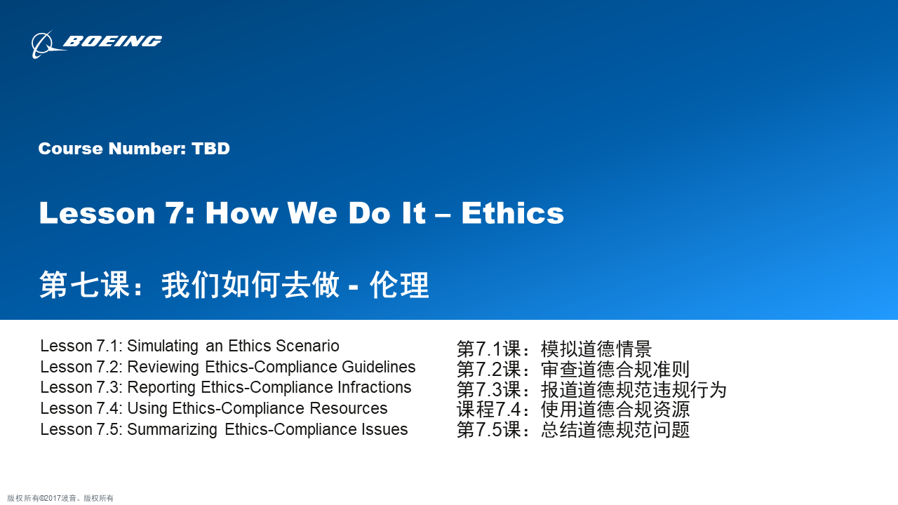

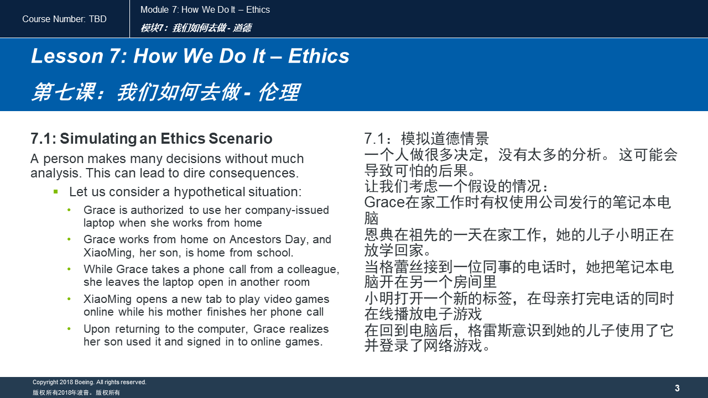
 | 5 Minutes
 | Ask | Ask learners to read the bullets on the slide to help increase participation and smooth out or “soften” the initial tenseness.
 | Say | This course provides a general overview of the role that ethics has in the workplace, as well as the way that employees are given the authority to report ethical violations regardless of who the person might be that is seen committing an infraction or suspected of committing an infraction or ethical violation.
 | Ask | What do you think? In the scenario, has Grace committed an infraction? If you think she has, raise your hand. Who wants to share their view?

 | Lesson 7: How We Do It – Ethics Slides XX–XX
 | 2 Minutes
 | Say | - Describe how ethics and compliance rules can help to create a positive and respectful workplace  - Describe the authorized actions an employee is allowed when using Company property  - Explain how Zhoushan Way mindset underlies company policy regarding ethics and compliance
 | Do | Tell participants that Grace’s potential infraction was a mistake, and mistakes must be reported, whether purposeful or not. Then offer a brief question and answer time to discuss how participants would describe if a mistake was purposeful.

 | Lesson 7: How We Do It – Ethics Slides XX–XX
 | 1 Minutes
 | Say | In this module, we will cover:  - A basic definition of ethics  - A specific view of ethics as it concerns the Completion Center and its employees  - The role for each employee to ensure that the Completion Center maintains strict integrity and honor

Lesson 7.1: Simulating an Ethics Scenario
Introduction
This lesson explains the way that Ethics supports and maintains positive behaviors in the workplace and also how to identify infractions that may result in negative consequences.
Estimated Learning Time
5 Minutes

 | Lesson 7: How We Do It – Ethics Slides XX–XX
 | 1 Minute
 | Say | Every thinking person has an opinion. Not just one, but many opinions ... about the best restaurant, nicest fashions, coolest music or most popular celebrity singer or actor. People can have differing views on what constitutes good and bad behaviors too. We will talk about that now.

 | Lesson 7: How We Do It – Ethics Slides XX–XX
 | 10 Minutes
 | Do | Form small groups. Tell learners to share among themselves certain “bad” behaviors in society. Tell them to use common everyday behaviors, but not ones that are illegal or illicit, but rather ones that may be considered rude or selfish.
 | Objective | Understanding and agreeing on what “bad” or “good” behaviors mean at the workplace will–it is hoped–lead to harmony and cooperation among employees.

 | Lesson 7: How We Do It – Ethics Slides XX–XX
 | 5 Minutes
 | Ask | Why does Grace need to do anything? It’s possible that nothing bad happened, correct?
 | Explain | Grace must do something. Her failure to notify a manager or the Ethics or Compliance Line could lead to serious allegations of misconduct against her for what others may claim was an attempt to “cover up” a wrongdoing.

 | Lesson 7: How We Do It – Ethics Slides XX–XX
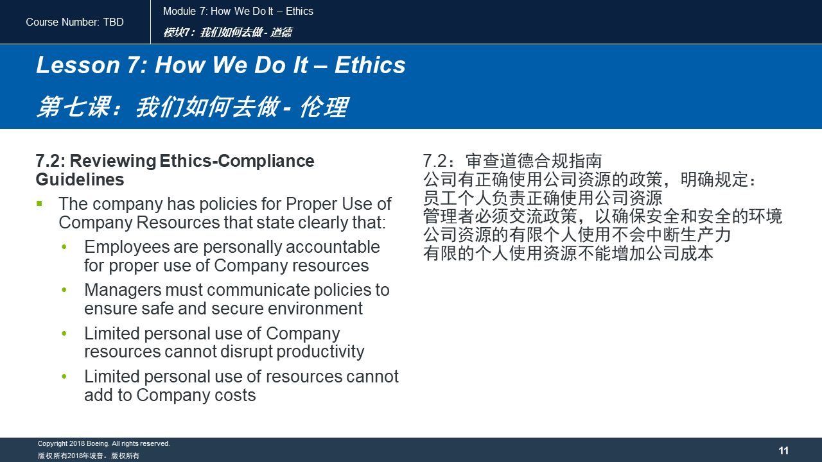
 | 5 Minutes
 | Say | To illustrate the principle: Think of a minor accident that could cause you to slip and fall. You can rise to your feet, but you have a pain in your hip area that made impact with the hard ground when you fell. You could choose to ignore it.  If the pain persists, however, you may be allowing a malignancy of some kind to injure your body. The prudent wise-thinking person would visit with a doctor to avoid negative consequences affecting your health. It is a similar situation with Grace in the scenario we have looked at. There is a possibility that the Company computer was infected. If she chooses to ignore that possibility and not report it, she allows the opportunity for a computer hacker or virus to create much greater damage.
 | Ask | What might be a possible outcome if Grace ignores the problem?  - Answer: A ransomware attack makes public the IP number and Grace can be identified as a Completion Center employee responsible for allowing a hack of her Company-owned laptop.  What might be a possible outcome if Grace immediately reports the problem?  - Answer: Completion Center data security staff conducts a comprehensive battery of threat assessment diagnostics that detects a Trojan horse and terminates the threat within 12 hours.
 | Do | Encourage learners to be wise and always report incidents that could cause bigger problems so the Company and employees can save face and restore harmony in the workplace.
 | Transition | Transition to providing learners with the proper resources to report ethical violations, or noncompliance of any kind, whether intentional or as in Grace’s situation, unintentional.

Lesson 7: How We Do It – Ethics
Introduction
This lesson explains the resources Completion Center employees can use to report suspected infractions.
Estimated Learning Time
3 Minutes

 | Lesson 7: How We Do It – Ethics Slides XX–XX
 | 3 Minutes
 | Explain | You can find this information on the Company intranet and in the Employee Handbook too.

 | Lesson 7: How We Do It – Ethics Slides XX–XX
 | 3 Minutes
 | Say | You can see now that reporting an ethics or compliance infraction is the best remedy for yourself, a colleague, and the Company.

 | Lesson 7: How We Do It – Ethics Slides XX–XX
 | 10 Minutes
 | Say | Ethics and Compliance Resources are the tools we use to make sure the Company, and our career, does not experience a crash landing!

 | Lesson 7: How We Do It – Ethics Slides XX–XX
 | 10 Minutes
 | Say | Ethics and Compliance Resources are the tools we use to make sure the Company, and our career, does not experience a crash landing!

 | Lesson 7: How We Do It – Ethics Slides XX–XX
 | 2 Minutes
 | Explain | Explain that the Completion Center is faced with a great challenge:  To create an environment of exacting specifications for the aircraft that employees will finish here––as well as the highest concerns for workers who will be free from causing reputational damage to the company.  The shared mission among employees of all position is to secure a positive and harassment-free workplace so that anxiety is minimized and contentment is maximized

 | Lesson 7: How We Do It – Ethics Slides XX–XX
 | 5 Minutes
 | Ask | What are other ethics or compliance issues that you can raise based on the hypothetical scenario with the fictional characters Grace and XiaoMing?  - Answers may include the following:  - XiaoMing might be accused of hacking into the Company server even if he was innocent  - The consequences could be severe for Grace if a breach of security was committed  If it was determined that Grace compromised employee information, could her coworkers sue her in court?  - Answers may include the following:  - That would be a question a Company ethics and compliance specialist could provide  - Employee handbook may be able to provide answers too

